**BUG #1**

**Title**:

Search room by all fields: not correct result

**Severity**

Critical

**Description**

Steps to reproduce:

1. Open Rooms managements screen

2. Search for “Triple” on the search part

**Expected**: Result of research with only “Triple” on the Room title/Hotel/Room type/ Qty

**Actual**: Get Standard Room type

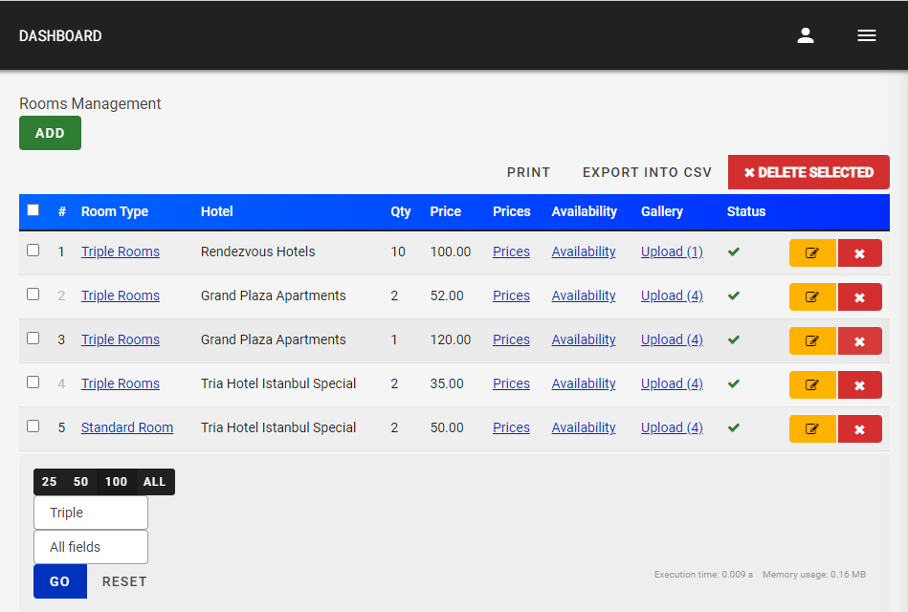

**BUG #2**

**Title**:

Making a research without filling the research box

**Severity**

* + Critical

**Description**

1. Open Rooms managements screen

2. Making a research without filling the research box and choosing a special type of reseach

**Expected**: All the Rooms the web site have

**Actual**: List of special rooms without understanding why

